The following questions assess the criteria: “detailed description and explanation of links between concepts, terminology, processes, and principles”

- What is data independence? Briefly explain this concept, making reference to the three-schema architecture:
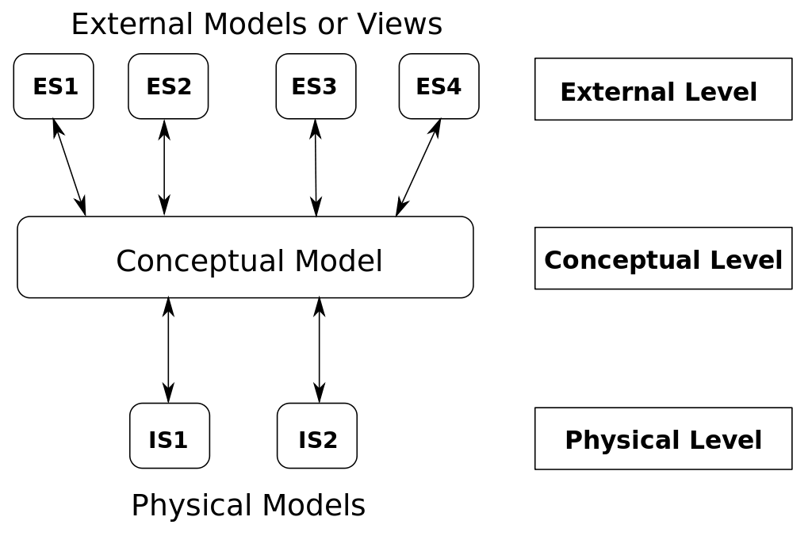 | Physical data independence is
Logical data independence is

- In conceptual schema development, what is meant by an elementary fact?
An elementary fact is

- Label the 8 CSD elements shown over the page using only the best fitting label from this table:
Quaternary Role | Value Object | Unary Role | External Uniqueness Constraint
Mandatory Constraint | Derivation Rule | Subtype | Simple Uniqueness Constraint
Range Constraint | Frequency Constraint | Nested Fact | Compound Uniqueness Constraint
Value Constraint | Exclusion Constraint | Ternary Role | ONF Algorithm
Subset Constraint | Equality Constraint | Super-type | External Mandatory Constraint

Element | Label | Element | Label

- List three methods of maintaining data integrity in a database:
i:
ii:
iii:

- Explain the concept of referential integrity using the terms parent table and child table in your explanation:
Referential integrity is

- What is the difference between a primary key and a foreign key?
A primary key is

A foreign key is

- What is the goal of normalisation?
The goal of normalisation is

The following questions assess the criteria: “Detailed and effective application of set processes to solve simple and familiar problems”

- Identify the levels of normal form that the following relations satisfy:
Choices: UNF, 1NF, 2NF:
Table Relations | Level of Normalisation
Subject Description
Subject | Description
Maths | Numbers
Science | Chemicals
Art | Painting

Selection
Student ID | Subject
1 | Maths
1 | Science
2 | Art

Student
Student ID | Name
1 | Mary
1 | Mary
2 | John

Student ID | Name | Subject | Subject Description
1 | Mary | Maths, Science | Numbers, Chemicals
2 | John | Art | Painting

Student ID | Name | Subject | Subject Description
1 | Mary | Maths | Numbers
1 | Mary | Science | Chemicals
2 | John | Art | Painting

- Apply the ONF algorithm to the following conceptual schema. Draw on the schema to illustrate table groupings, using placeholder letters and numbers for table and field names. Write the table relations in the box below. You do not need to indicate FK relationships in your table relations:
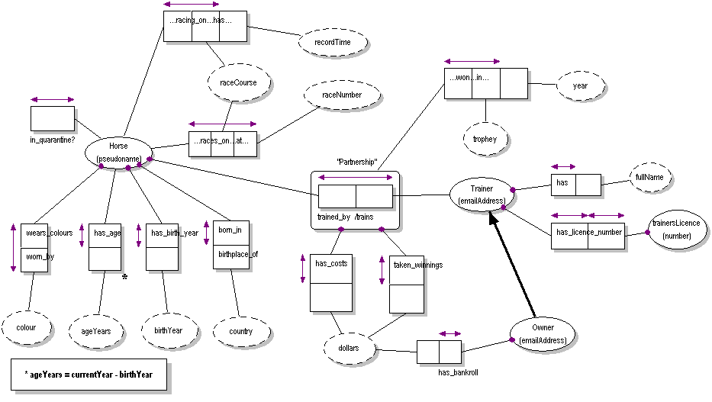

Write the resulting set of table relations here:

- A normalized set of table relations for an online digital content retailer has been created. A customer must authenticate by password before library purchases can be made (shown in the Library table):
Media
MediaID | Title | Category | Rating
413150 | Stardew Valley | Game | G
391540 | Undertale | Soundtrack | G
391541 | Undertale | Game | G

Accounts
Email | Password
jill@gmail.com | abcd1234
bob@yahoo.com | abcd1234

Library
Email | MediaID
jill@gmail.com | 413150
jill@gmail.com | 391540
bob@yahoo.com | 391540

Classifications
Rating | Description
G | General
PG | Parental Guidance

  - From the data provided, apply best fitting PK and FK constraints using lines and arrows:
Classifications ( Rating, Description )

Game ( MediaID , Title, Category, Rating )

Accounts ( Email, Password )

Library ( Email, MediaID )

  - Given your constraints, would the following highlighted transaction be allowed to be added, based on the existing data set? Explain:
Library
Email | App
jill@gmail.com | 413150
jill@gmail.com | 391540
bob@yahoo.com | 391540
sue@live.com | 413150

  - Assume the Media table referenced above was created with the following DDL:
CREATE TABLE IF NOT EXISTS Media (
MediaID INTEGER NOT NULL UNIQUE,
Title TEXT NOT NULL,
Category TEXT NOT NULL,
Rating TEXT NOT NULL,
PRIMARY KEY (MediaID)
FOREIGN KEY (Rating)
REFERENCES Classifications(Rating)
ON DELETE RESTRICT
ON UPDATE CASCADE
);

What is the implication if an operator makes these changes to the Classifications table:
- Modifies the existing PG classification to PGR (Parental Guidance Recommended)

- Tries to remove the G classification

End of Knowledge and Application questions.

Stimulus for remaining Analysis, Synthesis and Evaluation questions:
Stimulus Identification
Client | Queensland Courts
Your role | For this question, you assume the roles of an information systems analyst, designer and developer.
Identification of Problem | Queensland Courts are experimenting with “wireframe”, proof-of-concept relational information system solutions that can:  - Record claimant and defendant details  - For each case:  - Assign a court room (available numbers 1-3), hours needed (between 1-6), and whether transcription services are required  - Assign a judge to preside over the case, and make case notes as necessary  - Keep a register of Judge JP numbers (as per Australian Law)  The system must also:  - Ensure data integrity  - Perform due diligence by meeting considered social and ethical expectations in all its practises  You are welcome to make your own explicit assumptions for any information not presented here, provided they are justified.
UoD Glossary | Claimant: the person making or filing the claims or complaints  Defendant: the person accused of wrong-doing  JP number: Justice of the peace number. Every Judge must have their own unique JP num.  Transcribing: Record the discussions had in a court room on paper.
Sample Raw Data
Claimant | Claimant Contact | Defendant | Court Appearance Date | Court Room # | Hours Needed | Needs Transcribing? | Case Judge Assigned | JP Num | Case Notes
JB Fortran | 0465 185 194  (07) 3818 8549 | B Pascal | 7 Sep | 1 | 4 | Y | R. Leah | 34941 | Not happy with the outcome, appealing the decision.
B Pascal | (07) 4038 1059 | JB Fortran | 8 Sep | 1 | 3 | Y | R. Leah | As above. | Counter-suing JB Fortran. This could get ugly.
Alan Turing | Same as B Pascal’s | JB Fortran | 9 Sep | 1 | 4 | N
JB Fortran | Same as above | B Pascal | 15 Oct | 1 | 4 | Y |  |  | Claimant is finally happy with the decision.
JB Fortran |  | Alan Turing | 17 Nov | 1 | 3 | N | Y. Fellini | 78916 | A new case involving something else.
M Python | 0411 421 312 | B Pascal | 17 Nov | 2 | 3 | N

The following question assesses the criteria: “Detailed interpretation and analysis of problems and situations from multiple perspectives”
Deconstruct and interpret the stimulus above to analyze required specifications for the information system component of the Queensland Courts system. Your analysis should include:
- a Level 1 DFD illustrating “multiple perspectives” as external entities, showing the information flow, processes and data sources involved in Queensland Court operations.
- a measured consideration of the problem and situation, in brief point-form, which may include:
  - elementary facts required for conceptual mapping
  - social and ethical issues
  - other constraints or considerations prior to implementation.
Space below for analysis diagram(s):

Space below for analysis writing:

The following question assesses the criteria: “designed and developed effective solutions to unrehearsed or complex problems”

Design and develop a conceptual and relational schema (i.e. a normalized set of table relations) ready for implementation for the Queensland Courts relational information system:

This space is for synthesis:

This space is for synthesis:

Write on the back of this page if more space is required.
The following question assesses the criteria: “… application of self-determined and prescribed criteria, reasoning and evidence to draw conclusions and make supported recommendations. ”

Evaluate your design by applying self-determined and prescribed criteria, reasoning or evidence to draw conclusions and make future recommendations. Your evaluation should determine at least one self-determined criteria, as well as reflecting logic and reasoning in evaluating judgments made.

Assumptions, risk assessments involving worse-case scenarios, and predictions on patterns and trends in data utilization can all be put forward in your evaluation, in order to help you make convincing arguments.

Prescribed Criteria | Definition
Ensure Data Integrity | Assure the accuracy and consistency of data in the Queensland Courts information system.
Meet Social and Ethical Expectations | Ensure that the proposed Queensland Courts information system meets expectations of its users regarding information security, privacy and usage.
Self-determined Criteria | Definition

This space is for diagrams supporting evaluation, or further writing if necessary:

End of exam.

Standards Matrix for this task:
Dimension | A | B | C | D | E
Knowledge and application | The student work has the following characteristics:  - detailed description and explanation of links between information system concepts, terminology, processes, and principles | The student work has the following characteristics:  - description and explanation of information system concepts, terminology, processes, and principles | The student work has the following characteristics:  - description of information system concepts, terminology, processes, and principles | The student work has the following characteristics:  - statements of information system facts | The student work has the following characteristics:  - reproduction of isolated information system facts
 | - detailed and effective application of set processes to solve simple and familiar problems. | - effective application of set processes to solve simple and familiar problems. | - application of set processes to solve simple or familiar problems. | - elements of set processes to partially solve simple or familiar problems. | - elements of set processes used.
Analysis and synthesis | The student work has the following characteristics:  - detailed interpretation and analysis of problems and situations from multiple perspectives | The student work has the following characteristics:  - interpretation and analysis of problems and situations | The student work has the following characteristics:  - analysis of problems and situations | The student work has the following characteristics:  - identification and classification of problems or situations | The student work has the following characteristics:  - restated problems or situations
 | - designed and developed effective solutions to unrehearsed or complex problems. | - designed and developed solutions for unrehearsed or complex problems. | - designed and developed partial solutions for unrehearsed or complex problems. | - designed or developed elements of solutions for unrehearsed or complex problems. | - superficial elements of unrehearsed or complex problems.
Evaluation and communication | The student work has the following characteristics:  - … application of self-determined and prescribed criteria, reasoning and evidence to draw conclusions and make supported recommendations. | The student work has the following characteristics:  - … application of prescribed criteria, reasoning and evidence to draw conclusions and make supported recommendations | The student work has the following characteristics:  - … application of prescribed criteria, reasoning or evidence to draw conclusions and make recommendations | The student work has the following characteristics:  - … draws inferences | The student work has the following characteristics:  - elements of testing
 | Note to Panel – An offline, supervised written technique doesn’t allow sufficient opportunity for “comprehensive testing of processes and solutions” – hence this criterion has been contextualised to reflect this. Evidence of “testing” can be found via other assessment techniques included in this folio of work. This change was mirrored in the schools Year 11 IPT Monitoring folio, to which Panel approved without comment.
 | - comprehensive construction of documentation and fluent presentation of information using suitable communication conventions to convey meaning appropriate to the context. | - effective construction of documentation and effective presentation of information using suitable communication conventions to convey meaning appropriate to the context. | - Construction of documentation and presentation of information using communication conventions to convey meaning. | - presentation of information using elements of communication conventions. | - presentation of information.
Comments:

